Liber ARCANORUM τωυ ATU του TAHVTI
QUAS VIDIT ASAR IN AMENTI
SVB FIGURA CCXXXI
LIBER CARCERORVM τωυ QLIPHOTH CVM SUIS GENIIS
ADDENTVR SIGILLA ET NOMINA EORVM

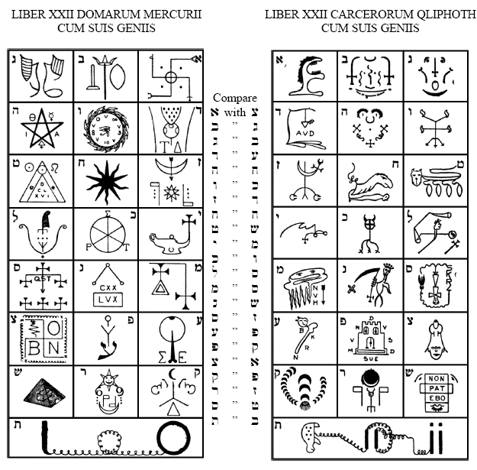
LIBER CCXXXI
(This book is true up to the grade of Adeptus Exemptus. V.V.V.V.V. 8°, 3□.)
0. A, the heart of IAO, dwelleth in ecstasy in the secret place of the thunders. Between Asar and Asi he abideth in joy.
1. The lightnings increased and the Lord Tahuti stood forth. The Voice came from the Silence. Then the One ran and returned.
2. Now hath Nuit veiled herself, that she may open the gate of her sister.
3. The Virgin of God is enthroned upon an oyster-shell; she is like a pearl, and seeketh Seventy to her Four. In her heart is Hadit the invisible glory.
4. Now riseth Ra-Hoor-Khuit, and dominion is established in the Star of the Flame.
5. Also is the Star of the Flame exalted, bringing benediction to the universe.
6. Her then beneath the winged Eros is youth, delighting in the one and the other. He is Asar between Asi and Nepthi; he cometh forth from the veil.
7. He rideth upon the chariot of eternity; the white and the black are harnessed to his car. Therefore he reflecteth the Fool, and the sevenfold veil is reveiled.
8. Also cometh forth mother Earth with her lion, even Sekhet, the lady of Asi.
9. Also the Priest veiled himself, lest his glory be profaned, lest his word be lost in the multitude.
10. Now then the Father of all issued as a mighty whell; the Sphinx, and the dog-headed god, and Typhon, were bound on his circumference.
11. Also the lady Maat with her feather and her sword abode to judge the righteous. For Fate was already established.
12. Then the holy one appeared in the great water of the North; as a golden dawn did he appear. bringing benediction to the fallen universe.
13. Also Asar was hidden in Amennti; and the Lords of Time swept over him with the sickle of death.
14. And a mighty angel appeared as a woman, pouring vials of woe upon the flames, lighting the pure stream with her brand of cursing. And the iniquity was very great.
15. Then the Lord Khem arose, He who is holy among the highest, and set up his crowned staff for to redeem the universe.
16. He smote the towers of wailing; he brake them in pieces in the fire of his anger, so that he alone did escape from the ruin thereof.
17. Transformed, the holy virgin appeared as a fluidic fire, making her beauty into a thunderbolt.
18. By her spells she invoked the Scarab, the Lord Kheph-Ra, so that the waters were cloven and the illusion of the powers was destroyed.
19. Then the sun did appear unclouded, and the mouth of Asi was on the mouth of Asar.
20. Then also the Pyramid was builded so that the Initiation might be complete.
21. And in the heart of the Sphinx danced the Lord Adonai, in His garlands of roses and pearls making glad the concourse of things; yea, making glad the concourse of things.
THE GENII OF THE 22 SCALES OF THE SERPENT AND OF THE QLIPHOTH
a Aa'au-iao-ua'aa [a'a=Ayin ] . . . . . :Amprodias
b Bea'a-theta-aoooabitom . . . . . :Baratchial
g Git-omega-nosap-phi-omeg-allois . . . :Gargophias
d D-etanastartar-omega-theta . . . . . :Dagdagiel
h Hoo-oor-omega-ist . . . . . . :Hemethterith
w Vuaretza --- [a secret name follows] . . :Uriens
z Zoo-omega-asar . . . . . . . . :Zamradiel
j Chiva-abrahadabra-cadaxviii . . . . . :Characith
f Theta-ala'aster-a-dekerval . . . . . :Temphioth
y Iehuvahastana'a-theta-atan . . . . . :Yamatu
k Kerugunaviel . . . . . . . . :Kurgasiax
l Lusanaherandraton . . . . . . . :Lafcursiax
m Malai . . . . . . . . . :Malkunofat
n Nadimraphoroiza'a-theta-alai . . . . :Niantiel
s Sala-theta-lala-amrodna-theta-a'aist . . . :Saksaksalim
u Oaoaaaoooa'a-ist . . . . . . . :A'ano'nin
p Pura-theta-metai-ap-eta-metai . . . . :Parfaxitas
x Xan-theta-asteransh-koppa-ist [sh koppa = sh, q] :Tzuflifu
q Qani-Delta-nayx-ipamai . . . . . :Qulielfi
r Ra-a-gioselahladnaimawa-ist . . . . . :Raflifu
c Shabnax-odobor . . . . . . . :Shalicu
t Thath'th'thitha'athuth-thist. . . . . . :Thantifaxath

