Hi All,
93
What's interesting about the article (below) is not only the Taoist connection; but for those that understand Crowley's Liber 36, there's a strong hint of what Alchemists call the 'Circulata'. There is a strong point to be made for energy loss in the spilling of semen and vaginal fluids (cf. my article: Liber Congregus Restituo) that is taught in several spiritual traditions. However, as the article mentions (and Crowley is the only Westerner to pick up on this and teach it!), when these fluids are orally consumed, there's a chance to "recapture the mythical time that existed before the division of the sexes" and is a major topic for those that follow Kenneth Grant's teachings.
In Alchemy, the Circulata is said to exalt the substance to a higher spiritual state by recycling its more spiritual components; causing first a steam that then re-coagulates into a liquid and falls back into the original substance. In my own lab, I do this with wine and using an ancient Alchemical flask; called the Pelican. The Pelican is described in some texts, also as the Phoenix, that which rises from the ashes...a resurrection. In sexual congress, the symbolism may now seem obvious. The energy and vitality given into the sexual juices (per Liber 36) is consumed by both partners, eucharistically, and then in a higher spiritual state. This is referred to as the elixir and is said to be at least a healing agent.
Crowley's diaries on Oesopus Island (NY) give some details of his experiments with this; but not in sexual coitus with a woman, only through onanistic technique. And there is some success here; but unfortunately, his misogyny also becomes obviously implicit. However, there is a little bit of a misnomer here. Woman (as well as men) in Christist culture have enough of a problem with sexual taboos, and viable partners; even in today's supposedly liberal culture, can be quite difficult to find.
Liber 36 is then written in symbolic fashion and for the lay reader might be impossible to interpolate. This work is the Thelemic equivalent of the hexagram ritual in more 'traditional' forms of Magick. And of course, the six-pointed star (so important to Thelemites) is the union of man (5-the pentagram) with God (1-the single point).
93/93
pj

Cunnilingus in Culture

In Religion and Sects
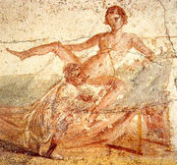
Cunnilingus portrayed at Pompeii
Although not spoken of openly in Western society until recently, cunnilingus is accorded a revered place in Chinese Taoism. This is because the aim of Taoism is to achieve immortality, or at least longevity, and the loss of semen, vaginal, and other, bodily liquids is believed to bring about a corresponding loss of vitality. However, conversely, by either semen retention or ingesting the secretions from the vagina, a male can conserve and increase his ch'i, or original vital breath. In Taoism:
The Great Medicine of the Three Mountain Peaks is to be found in the body of the woman and is composed of three juices, or essences: one from the woman's mouth, another from her breasts, and the third, the most powerful, from the Grotto of the White Tiger, which is at the Peak of the Purple Mushroom (the mons veneris).
– Octavio Paz. Conjunctions and Disjunctions. trans. Helen R. Lane. 1975. (London: Wildwood House, 1969) p. 97.
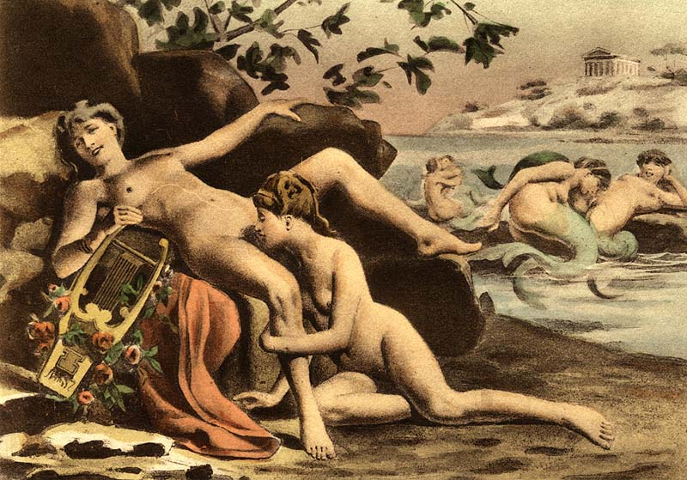

Édouard-Henri Avril drawing depicting the life of Sappho
According to Philip Rawson (in Paz, p. 97), these half-poetic, half-medicinal metaphors explain the popularity of cunnilingus among the Chinese: "The practice was an excellent method of imbibing the precious feminine fluid" (Paz, p. 97). But the Taoist ideal is not just about the male being enriched by female secretions; the female also benefits from her communion with the male, a feature that has led the sinologist, Kristofer Schipper, to denounce the ancient handbooks on the "Art of the Bedroom" as embracing a "kind of glorified male vampirism ", that is not truly Taoist at all.^{[3]} Ideally, by mingling the male and female liquids, the Taoist aims to reconcile opposites and to recapture the mythical time that existed before the division of the sexes, the primordial time of the original ch'i.
The religious historian, Mircea Eliade, speaks of a similar desire to transcend old age and death, and achieve a state of nirvana, in the Hindu practice of Tantric yoga. In Tantric yoga, the same emphasis is placed on the retention and absorption of vital liquids and Sanskrit texts describe how the male semen must not be emitted if the yogin is to avoid falling under law of time and death. ^{[4]}

Hi All,
93
It is interesting that I came across this this morning; after reading from Volume 2 of Blavatsky's Secret Doctrine...for I found the following:

Every Cosmogony began with a circle, a point, a triangle, and a cube, up to number 9, when it was synthesized by the first line and a circle -- the Pythagorean mystic Decade, the sum of all, involving and expressing the mysteries of the entire Kosmos; recorded a hundred times more fully in the Hindu system, for him who can understand its mystic language. The numbers 3 and 4, in their blending of 7, as those of 5, 6, 9, and 10, are the very corner-stone of Occult Cosmogonies.

As a preliminary, two verses from AL come to mind:

AL I.46: "Nothing is a secret key of this law. Sixty-one the Jews call it; I call it eight, eighty, four hundred & eighteen."

AL III.19: "That stele they shall call the Abomination of Desolation; count well its name, & it shall be to you as 718."

We find here, the number 18 attached to the numbers 4 and 7; referring to the last sentence in the above quote from HPB. 418 is the Great Work and 718 is the Stele of Revealing that is the outline for Thelemic Magick. 418 is also the number of Boleskine, expressed in Hebrew transliteration.

AL II.78: "Lift up thyself! for there is none like unto thee among men or among Gods! Lift up thyself, o my prophet, thy stature shall surpass the stars. They shall worship thy name, foursquare, mystic, wonderful, the number of the man; and the name of thy house 418."

The 3 and the 4, the triangle and the cube, or the male and female universal glyph, showing the first aspect of the evolving deity, is stamped for ever in the Southern Cross in the Heavens, as in the Egyptian Crux-Ansata. As well expressed, "The Cube unfolded is in display a cross of the tau, or Egyptian form, or of the Christian cross form. . . . A circle attached to the first, gives the ansated cross. . . numbers 3 and 4 counted on the cross, showing a form of the (Hebrew) golden candlestick (in the Holy of Holies), and of the 3 + 4 = 7, and 6 + 1 = 7, days in the circle of the week, as 7 lights of the sun. So also as the week of 7 lights gave origin to the month and year, so it is the time marker of birth. . . . The cross form being shown, then, by the connected use of the form 113 : 355, the symbol is completed by the attachment of a man to the cross.* This kind of measure was made to co-ordinate with the idea of the origin of human life, and hence the phallic form.**"
* Once more, remember the Hindu Wittoba crucified in space; the significance of the "sacred sign," the Swastica; Plato's Decussated man in Space, etc., etc.
** "Source of Measures."
"In the 'Naturalist,' published at Salem, Massachusetts, in one of the early numbers, is to be found a description of some very ancient and curious carving on the crest walls of the mountains of South America, older by far, it is averred, than the races now living. The strangeness of these tracings is in that they exhibit the outlines of a man stretched out on a cross,* by a series of drawings, by which from the form of a man that of a cross springs, but so done that the cross may be taken as the man, or the man as the cross; thus exhibiting a symbolic display of the interdependency of the forms set forth.
* See farther on the description given of the early Aryan initiation: of Visvakarma crucifying the Sun, "Vikkartana," shorn of his beams -- on a cruciform lath.
The importance of the "man stretched on the cross" as found in the traditional hexagram ritual; with its analysis of the 'key word' (INRI) is explained in the above paragraphs by HPB.
"The form of this pyramid (of Papantla) which has seven stories, is more tapering than any other monument of this kind yet discovered, but its height is not remarkable, being but 57 feet, its base but 25 feet on each side. However, it is remarkable on one account: it is built entirely of hewn stones, of an extraordinary size, and very beautifully shaped. Three staircases lead to the top, the steps of which are decorated with hieroglyphical sculptures and small niches arranged with great symmetry. The number of these niches seems to allude to the 318 simple and compound signs of the days of their civil calendar."
"318 is the Gnostic value of Christ," remarks the author, "and the famous number of the trained or circumcised servants of Abraham. When it is considered that 318 is an abstract value, and universal, as expressive of a diameter value to a circumference of unity, its use in the composition of the civil calendar becomes manifest."
The only numer not covered in AL is then 318. In Liber 777, it is shown to equal a Hebrew phrase that Crowley translates into Latin: Labrum lavacri, et basio eius.

Labrum is Latin for lip, and is used in a number of words including the word labia; though I can't seem to find a translation for lavacri. Basio seems to be a form of the word basium, which translates as kiss and I can't find a translation for eius. Kissing lips though, seems a part of this phrase.

It is interesting that in one of the fragments of the Gnostic Gospels, Jesus is said to kiss Mary on the [ ] ; and the fragment is lost; that completes the sentence. And I do believe that Crowley is giving us some hint here; if only the sentence could be properly translated. The online Latin dictionary doesn't help. Still, there seems an overt reference to the hexagram rite and Liber 36.

What remains of the numbers 3, 4 & 7 is the number 18. In Sepher Sepheroth, we get the following Hebrew words:
My favourite, my beloved
Hatred
The antique Serpent
Living
Notariqon of Yehi Aur, etc.

In the Sepher Sephiroth of the English Qabalah, I found the following values:
318 Binah
418 ThRShRQ of ABrtahadabra, The number of the Great Work, Khabs house, 'Lord of Creation', Baphomet, 'Shall Be', 'Two and Fifty-Five', Name of Dome Genii (Art Atu) Liber 231.
718 Six

93/93
pj

